IW-17
YEAR 9 SCIENCE
PHYSICAL SCIENCES
LIGHT AND HEAT TEST

NAME: CLASS: Mark: $\frac{}{\text{4}\text{3}}$

QUESTION | ANSWER
1
2
3
4
5
6
7
8
9
10
11
12
13
14
15
16
17
18
19
20
21
22
23
24
25
Multiple Choice Write the answer to each question in the appropriate box at right.

1. The electromagnetic energy we feel as heat is:

(a) infrared.
(b) ultraviolet.
(c) microwave.
(d) radio.

2. Which of the following measures the wavelength of a transverse wave?

(a) The distance between the top of a crest and bottom of a trough.
(b) The distance of the top of a crest above the bottom of a trough.
(c) The distance from the start of a wave to its end.
(d) The distance between the bottoms of two troughs.

3. Which of the following statements best describes the motion of particles in a transverse wave?

(a) The particles vibrate parallel to the direction of energy transfer.
(b) The particles vibrate at right angles to the direction of energy transfer.
(c) The particles gradually spread out parallel to the direction of energy transfer.
(d) The particles gradually spread out at right angles to the direction of energy transfer.

4. Refraction of light is:

(a) the wave motion of light as it passes through a substance.
(b) the bending of light as it passes from one substance into another.
(c) a reflection of light rays at the surface of a medium.
(d) the failure of light to pass through a very dense substance.

5. Light travels in lines.

(a) diagonal
(b) curved
(c) horizontal
(d) straight

Questions 6 and 7 refer to the following diagrams.

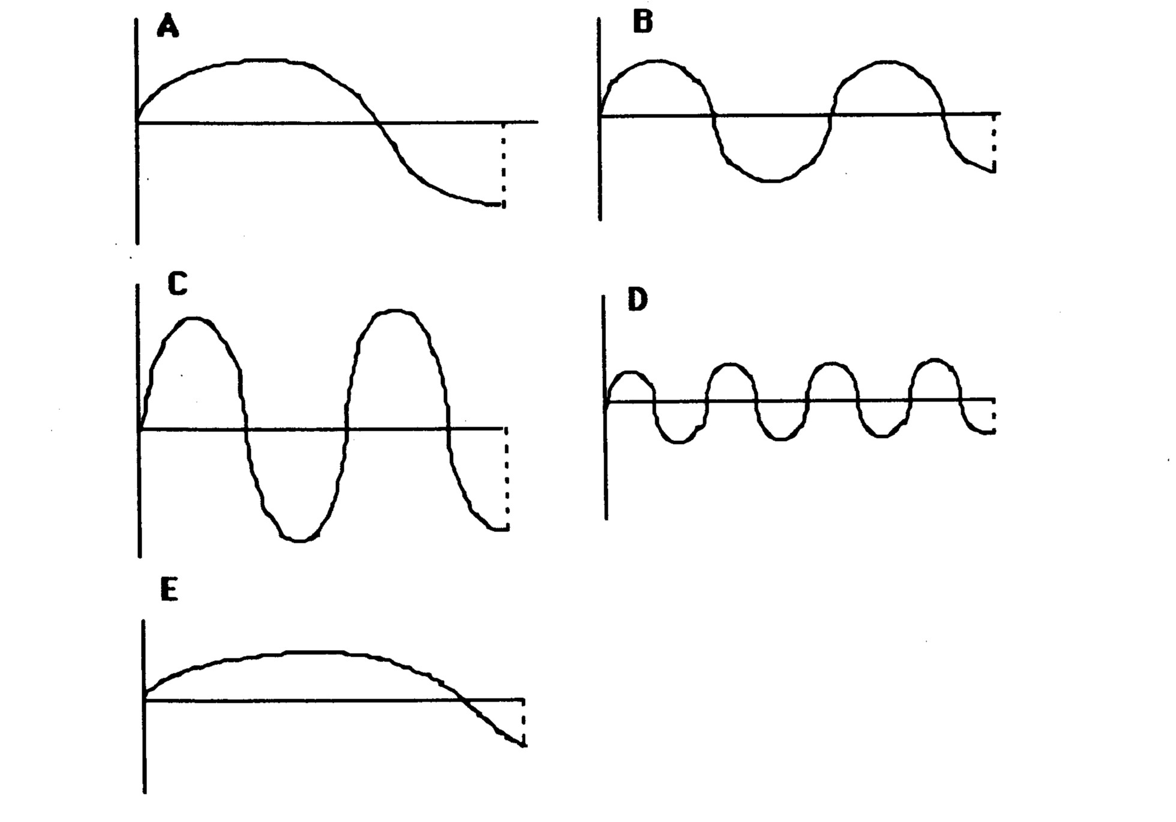

6. The wave with the greatest wavelength is:

(a) A
(b) B
(c) C
(d) D
(e) E

7. The wave with the greatest amplitude is:

(a) A
(b) B
(c) C
(d) D
(e) E

8. The greater the curvature of a convex lens:

(a) the more it bends light and hence the shorter the focal length.
(b) the more it bends light and hence the longer the focal length.
(c) the less it bends light and hence the shorter the focal length.
(d) the less it bends light and hence the longer the focal length.

9. Mirrors will light rays.

(a) scatter
(b) refract
(c) transmit
(d) reflect

10. Compared to visible light, ultraviolet radiation has:

(a) lower frequency and higher energy.
(b) higher frequency and lower energy.
(c) higher frequency and higher energy.
(d) lower frequency and lower energy.

11. Refraction can make it difficult to judge the depth of water. How is the light shown from the point in the diagram bent?
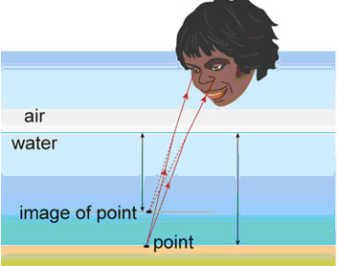

(a) Light from the point is bent towards the normal, making the point seem deeper.
(b) Light from the point is bent away from the normal, making the point seem shallower.
(c) Light from the point is bent towards the normal, making the point seem shallower.
(d) Light from the point is bent away from the normal, making the point seem deeper.

12. A man has a black patch over his right eye. He looks into a plane mirror. Which of the following diagrams best describes the image he sees?

 | (a) | 
 | (b) | 
 | (c) | 
 | (d) | 

13. Identify the correct statement about reflection of light.

(a) The angle of incidence equals the angle of refraction.
(b) The reflective coating is commonly placed on the back surface of a plane mirror.
(c) The law of reflection only applies to plane mirrors.
(d) Parallel rays of light are reflected to a focal point in a convex mirror.

14. Which of the following statements about light is false?

(a) Light can travel through opaque substances.
(b) Light can travel through space.
(c) The speed of travelling light can change.
(d) The density of a substance determines how light behaves when entering it.

15. If you put a hot brick into a bucket of cold water, heat transfers from the:

(a) water to the brick.
(b) brick to the air.
(c) brick to the water.
(d) air to the water.

16. During heat transfer by convection:

(a) energy transfers through a substance, but none of the substance itself moves.
(b) energy transfers through liquids and gases by tiny currents that carry the energy.
(c) energy transfers across empty space or through another substance without heating it.
(d) conduction and radiation always occur as well.

17. A substance (or medium) is needed to transfer heat energy in the case of:

(a) radiation.
(b) conduction.
(c) conduction and convection.
(d) radiation and conduction.

18. A sound wave consists of a series of alternate regions of high and low pressure called:

(a) vibrations.
(b) alternating frequencies.
(c) different media.
(d) compressions and rarefactions.

19. Light going from air into glass:

(a) speeds up slightly and bends towards the normal.
(b) speeds up slightly and bends away from the normal.
(c) slows down slightly and bends away from the normal.
(d) slows down slightly and bends towards the normal.

20. A convex lens is a piece of glass or plastic used to bend light. It is:

(a) even in thickness.
(b) narrower at each end than at its centre.
(c) wider at each end than at its centre.
(d) narrow at one end and thick at the opposite end.

21. Compare the way that dark and light substances absorb and emit radiation.

(a) Dark objects absorb less and release less radiation than light coloured objects.
(b) Dark objects absorb less and release more radiation than light coloured objects.
(c) Dark objects absorb more and release more radiation than light coloured objects.
(d) Dark objects absorb more and release less radiation than light coloured objects.

22. If a metal rod is placed in a fire, heat travels along it by:

(a) convection.
(b) insulation.
(c) radiation.
(d) conduction.

23. Which of the following is an example of convection of heat?

(a) Smoke from a fire always rises up over the fire.
(b) Many stainless steel saucepans have aluminium bases.
(c) Solar hot water systems on a roof are painted black.
(d) Electric heaters have silver coloured reflectors behind the elements.

24. If you sit on the edge of a swimming pool and dangle your leg in the water, your leg appears to bend where it enters the water. This is because of a behaviour of light called:

(a) diffuse reflection.
(b) refraction.
(c) regular reflection.
(d) absorption.

25. Which of the following best describes the meaning of conduction of heat?

(a) It is the transfer of heat due to the movement of groups of energetic particles.
(b) It is the transfer of heat due to collisions between neighbouring vibrating particles.
(c) It is the transfer of heat due to the emission of infra-red radiation.
(d) It is the transfer of heat due to the flow of electrons.

Short Answer Write the answer to the questions in the spaces provided.

1. (a) Label the following diagram. (4 marks)

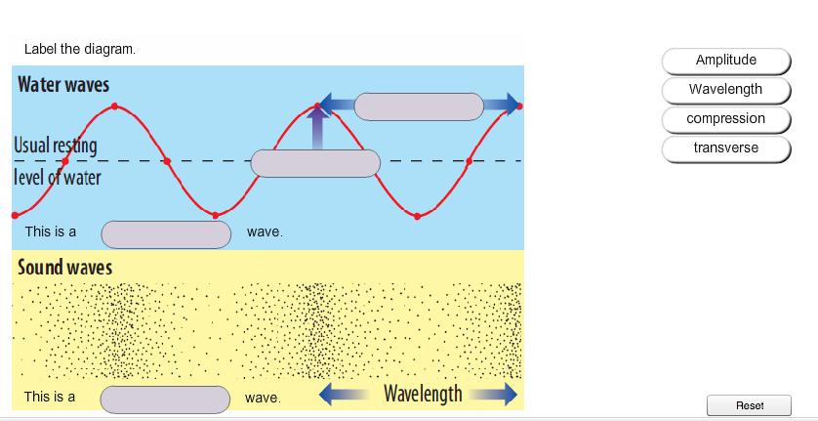

(b) Which of these (transverse or longitudinal) describes a light wave? (1 mark)

2. Draw the path of the rays in the following diagrams. (5 marks)

3. Label the compressions and rarefactions in the diagram below. (2 marks)
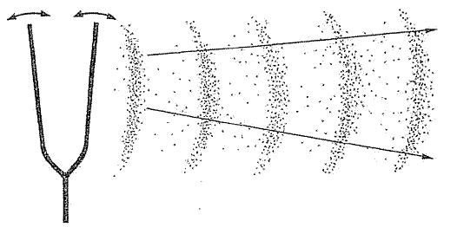

4. (a) Complete the diagram of the electromagnetic spectrum by naming the remaining bands. (4 marks)

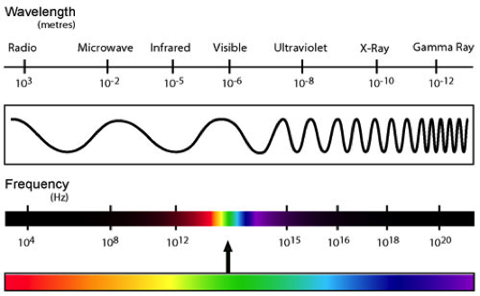
C
D
A
B

A: B:

C: D:

(c) Of the visible light spectrum (R O Y G B V), which colour of light has the lowest frequency?

(1 mark)

(d) Of the visible light spectrum (R O Y G B V), which colour of light has the highest energy?

(1 mark)

